Challenge Task 2

Reza Shisheie

2708062

The goal of this challenge task is to change color of marker once it goes to a certain area and wipes the whole canvas once it goes to other area.

To achive this goal, the location of the tracked joint is used. Once the location of X and Y of the joint goes to certain X and Y location which is denoted by the large circle it changes the color of the drawing tool or wipes the whole canvas:

This change is done in the “MapJointsWithUIElement(Skeleton skeleton)” method:

if (bone.X1 > 500 && bone.Y1<50)

{

canvas1.Children.Clear();

}

if (bone.X1 > 500 && bone.Y1>200)

{

bone.Stroke = Brushes.Yellow;

}

Here are two screen shots of my app:

This one shows the cursur when it is moved to the bottom area and color is changed to yellow:

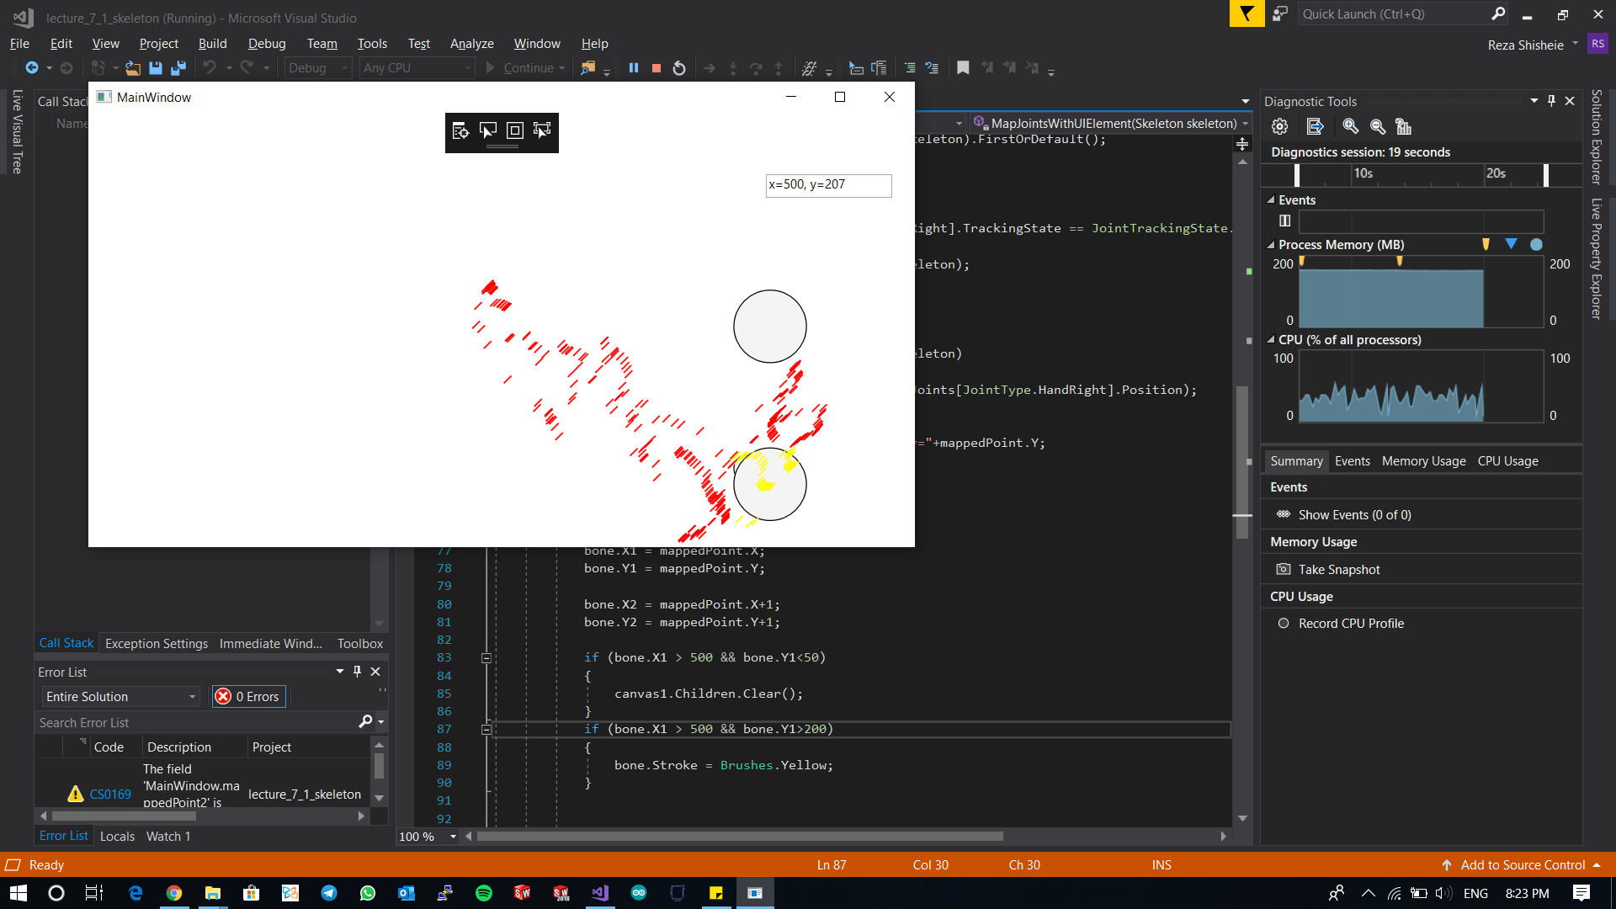

This one wiped the whole canvas when moved to upper area:

